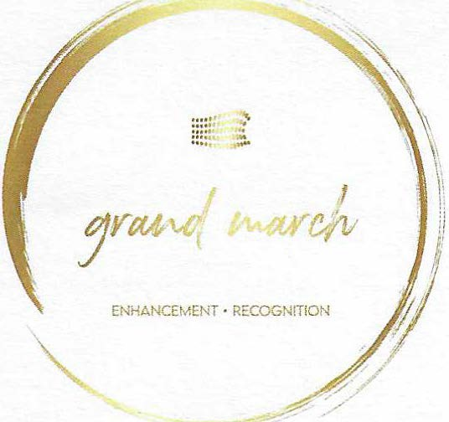

Chairperson Ron Nagy roncyn@aol.com 248.217.1850

Vice Chairperson Scott Strickler Sjstrick9@charter.net 810.423.4815

Secretary
Bill Bupp w.bupp@comcast.net 517.927.8808

Treasurer
Don Nagy donnagy1@comcast.net 586.999.1621

Board Members Karen Leinaar karenleinaar@gmail.com 231.218.6983

Steve Ley stephenjley@yahoo.com 989.737.6923

John Bishop
johnnyb49010@gmail.com
269.650.5166

Ex-Officio
Dan Hutcheson (MHSAA) dan@mhsaa.com

Shelby Bupp Crockett shelbybupp@gmail.com

Special Assistant John Andrews dja@djandreslaw.com 248.505.3644

3991 White Pine Drive DeWitt, Michigan 48820
To: Whom it may concern:
I am writing to you on behalf of the Grand March Foundation which supports the Michigan High School Athletic Association (MHSAA) Individual Wrestling Finals. This tournament, which is held at The Ford Field, is the largest of its kind in the United States and differs from all other MHSAA events. It brings 1,120 student-athletes and 1,700 coaches from across the State of Michigan under one roof to create a single competition. Since its inception, this tournament has seen annual increases in attendance, and recently eclipsed 50,000 spectators over the course of two days. This event is made possible through the support of the MHSAA and the 280 volunteers who work tirelessly to make the tournament a continued success.
Although the MHSAA provides funding for the majority of the tournament, there are some expenses outside the scope of their contribution. The Grand March Foundation was created to offset these additional costs. These additional expenses include meals and clothing for the volunteers, equipment and supplies, as well as a keepsake for each wrestler. Although only half of the participants will qualify for a medal, a gift recognizes the accomplishments of each athlete, and provides a memento of their participation in the tournament.
The Grand March Foundation through the MHSAA is recognized as a 501(c)(3) charitable organization which makes donations tax- deductible (EIN: 92-0918647), and all contributions directly benefit the continued success of this annual event. Donations range from small individual contributions to larger corporate sponsorships. There are a variety of options for contributing and any amount is welcome.
Contributions are flexible and negotiable.
Your support will help ensure that this event remains a tremendous success for years to come. The upcoming tournament begins Friday, March 1, 2024 and ends Saturday, March 2, 2024. If you would like to be a part of this event, or if you have any questions regarding our organization, contact us. Your consideration is greatly appreciated.
Warmest regards,

Ron Nagy Tournament Manager
(248) 217-1850
ronnagy309@gmail.com

Visit Website: https://grandmarchfoundation.com

